**CDE Micro-Credential Program**

**HackerRank Assessment Guidelines**

* The assessment duration is 2hrs and needs to be completed in one-sitting without breaks in-between.
* You would receive hackerRank Assessment invite mail from an external email ID (Cognizant Hiring Team <support@hackerrankforwork.com>) before/on the selected date as shown in the following screenshot.

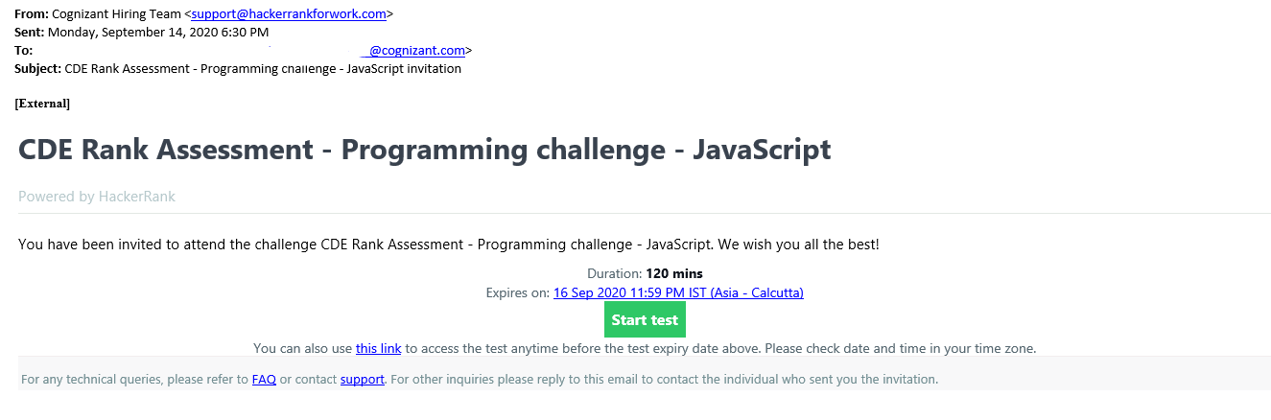

* When you are available for2 hours Click on ‘*Start Test’* from the mail to start the test.

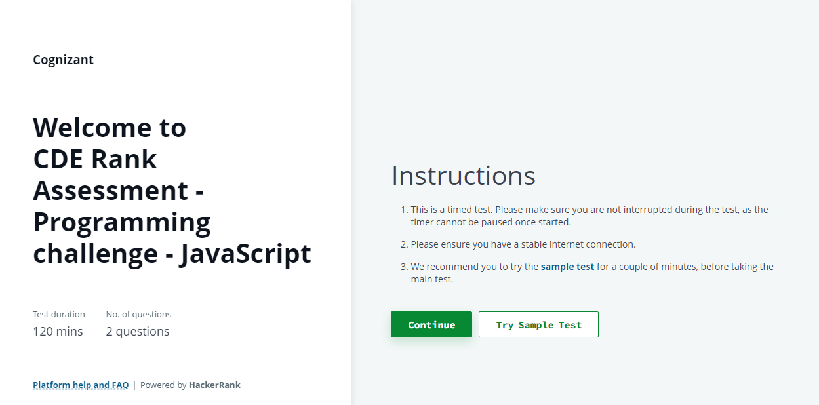

* Click ‘*Continue*’ and provide your Cognizant Email and password to login.

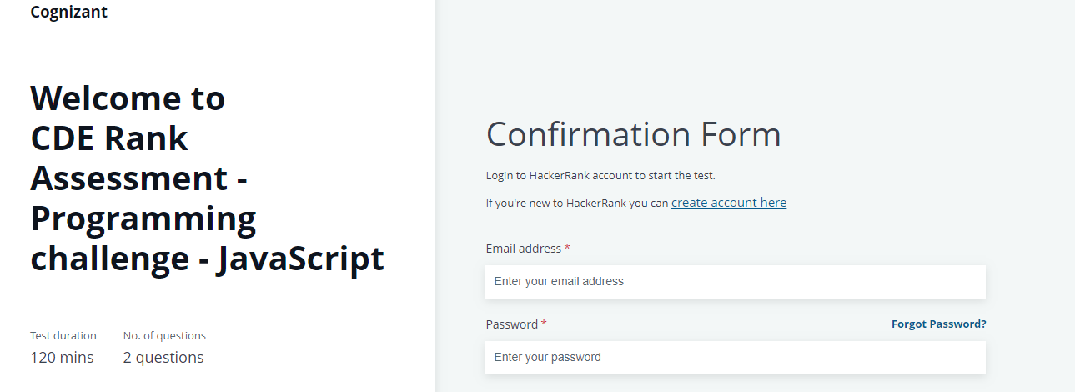

* If you are taking hackerrank test for the first time, click on create account and provide cognizant mail id and password and signup.
* Provide your Work Experience in years and check the declaration statement checkbox. Click on ‘***Agree & Start’*** and this will navigate to the coding challenge page.
* You will be provided with two questions and Click ‘*Solve question’* to start with solving the question. You will find the timer running in the upper left hand corner.
* Your test setter may include one or more test cases to validate your solution to a coding problem. These test cases are automatically executed when you run your code, and they validate different simple and corner scenarios using your solution to return the output. The execution status of each test case is displayed separately.
* Click on *Submit Code/Test* once you complete your coding questions.

**Note:**

1. The score for your coding solution is calculated and assigned based on the number of test cases that execute your logic successfully to produce the exact expected output. Scoring for successfully running test cases are not same, it is based on the difficulty level of the test case.
2. If associate face any network issues, all the work that associate submitted before losing the internet connection is saved on hackerrank servers. After the internet connectivity is resumed, you can log on to the test again (if it is not passed the test completion time) and resume answering the questions. However, it is best to check your computer and internet connection before taking the Test.